Practical Record: Local AI API Testing with Ollama, Postman and Python

Introduction
This experiment demonstrates how a local Large Language Model can be accessed through REST APIs. Postman is used for manual testing while Python's requests library is used for automation. The activity verifies successful communication using HTTP requests and JSON data.

Objectives
- Study basic Ollama commands.
- Send GET and POST requests.
- Test the Ollama local API.
- Interpret the returned JSON response.

Workflow
- Install and verify Ollama.
- Download the llama3 model.
- Start the Ollama server.
- Test APIs in Postman.
- Execute the same request using Python.

Screenshots and Explanation
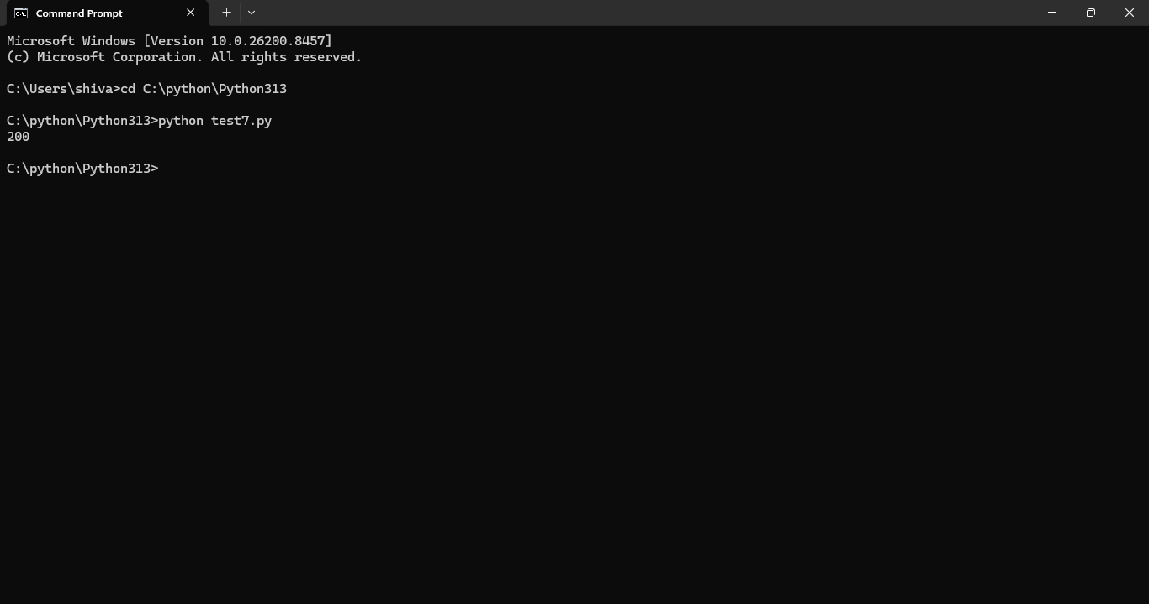
Figure: HTTP GET request returned status code 200, confirming successful connectivity.
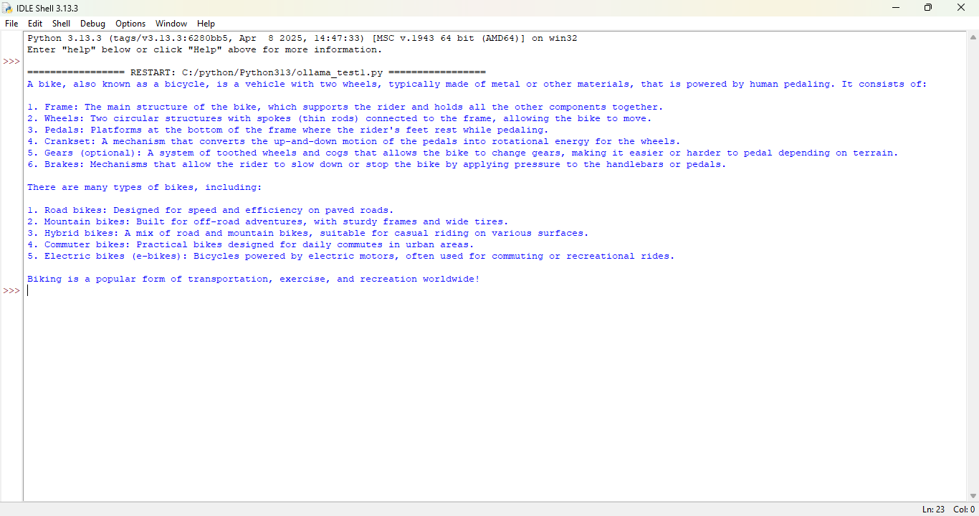
Figure: Python IDLE displaying AI-generated output from the Ollama model.
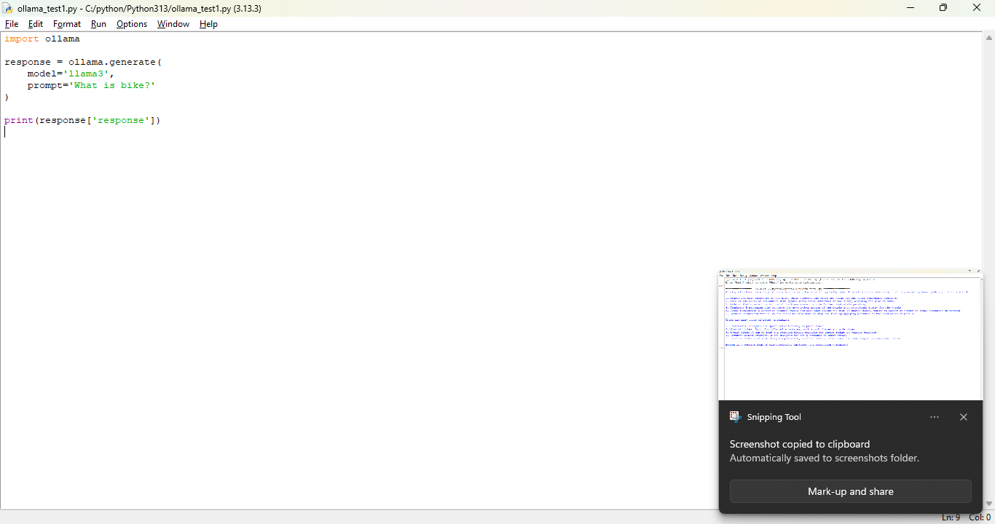
Figure: Python program using the Ollama library to generate a response.
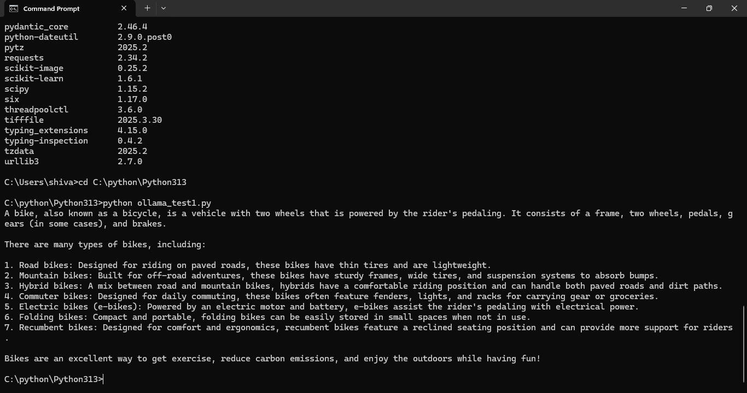
Figure: Command Prompt showing generated text from the local model.
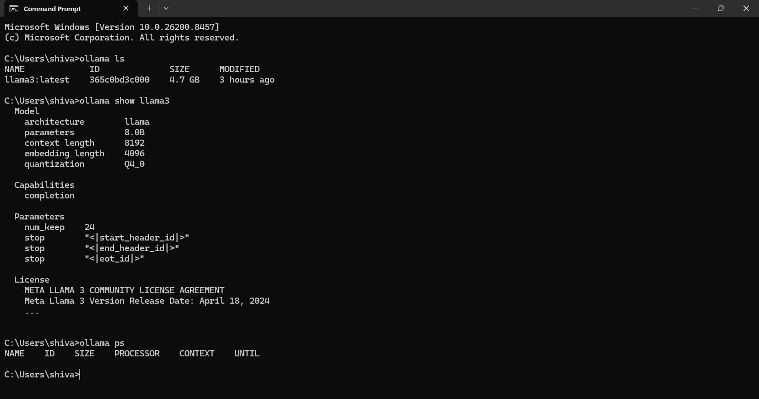
Figure: Installed model information and Ollama command outputs.
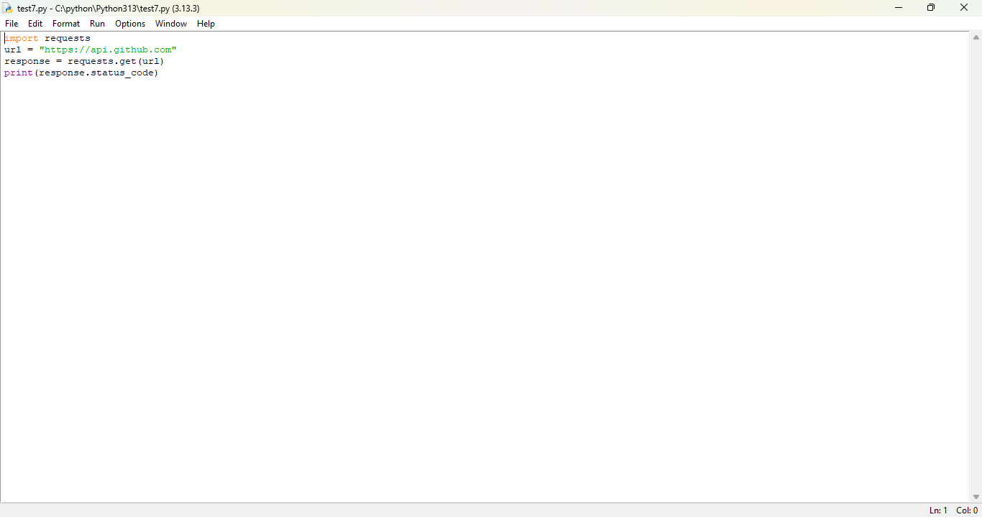
Figure: Python code demonstrating a simple GET request.
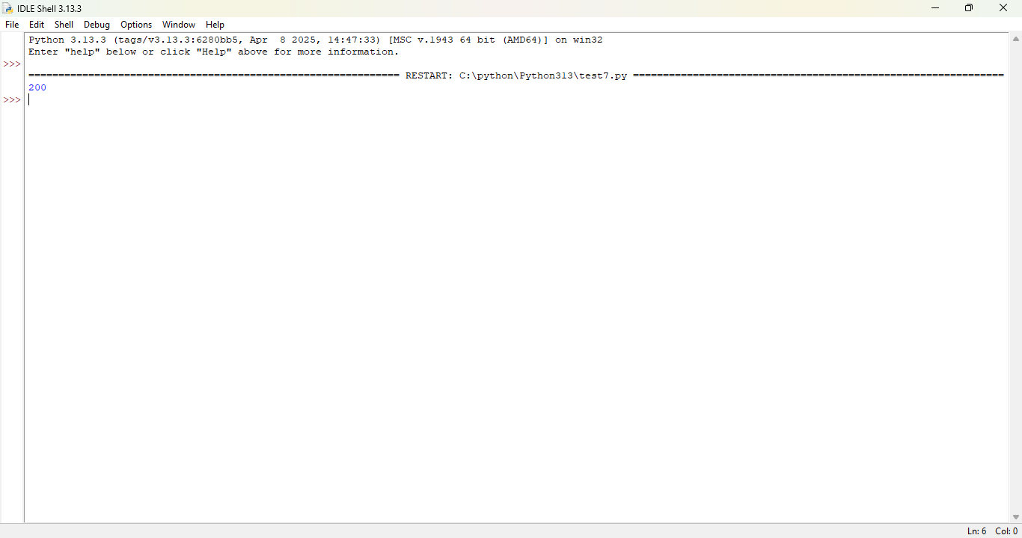
Figure: Execution result showing HTTP status code 200.
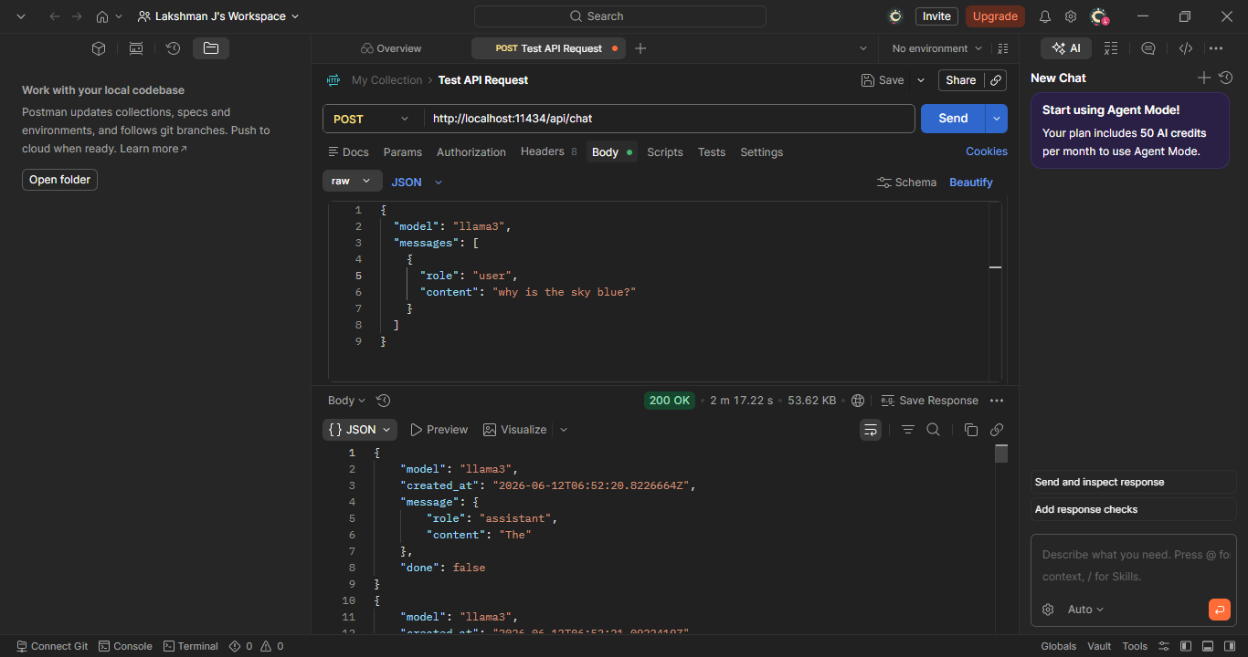
Figure: Postman sending a POST request to the local Ollama API.

Conclusion
The experiment successfully demonstrated API communication using both graphical and programmatic methods. Local AI models can be accessed through standard HTTP requests, making Ollama a convenient platform for offline AI development and testing.

